


PROJECT REPORT

Website design and sell

Semester: I

Class: SE01

Group: Group 3

Instructor Võ Công Đình

Team members: Võ Thị Thanh Huyền

Trương Công Hiếu Nguyễn Thùy Linh



Website design and sell
I. Project introduction 3
II. Analyze System Requirement 4
1. Use Case 4
1.1 Use Case 4
1.2 Login description 6
1.3 Product browsing description 7
1.4 Search description 7
1.5 Post product description 8
1.6 Design product description 9
1.7 Update cart description 9
1.8 Invoice detail description 10
1.9 Payment description 10
2. Activity Diagram 11
2.1. Login 11
2.2. Registration 12
2.3. Search 12
2.4. Payment 13
2.5. Add to cart 13
2.6. Post products 14
2.7. Browse products 14
III. Design Details 15
1. UI Design 15
1.1 Login 15
1.2 Menu customer 15
1.3 List product 15
1.4 Menu seller 16
1.5 Add product 16
1.6 Menu admin 16
1.7 List customer 16
1.8 List seller 17
2. Code Design (Class Diagram) 17
3. Sequence Diagram 19
3.1. Login 19
3.2. Search 20
3.3. Add product to cart 21
3.4. Post products 22
3.5. Order 23
4. Database Design 24
4.1. Entity relationship diagram 24
4.2. Database Design Details 25
IV. TaskAssign ( to each team member) 29

- Project introduction

The system provides the main functions: product design, buy and sell designer products.

Besides, there are also the following additional functions: ordering, posting for sale, payment, managing personal products.....

  - Proposed System
- Create a feature to Customers order.
- Create a feature for Sellers to design products and post them for sale
- Create a feature to Administrators to post, manage original products and manage items and orders available on the web platform.
- Create a feature for the order shipping facility to update the order shipping process
  - The scope of the project to be applied
- Make for actor are Seller and Admin and Customer
  - System Name

- Design combined sales
  - Deployment Environment
- Windows, Linux, Mac
  - Development Tools
- Visual Studio Code
- Draw.io Digram
- MySQL Workbench 8.0 CE
- Figma
  - Customer Requirements
- Interface requirements:

+ Creative, simple, easy to use, clear categories

+ Easy to see, uniform, not too many colors

+ Standard, clear image.
- Product requirements:

+ Display product information and images.

+ Search products.

+ Show the design on the product and the meaning if any
- User (client) functionality requirements

+ Login, register

+ Manage personal information

+ View shop list and product list

+ View and update cart

+ View purchase invoices

+ Choose payment method

+ Rate and view reviews of products

+ View product shipping information
- System administrator (admin) function requirements

+ Manage customer information

+ Manage posted products and original products

+ System data storage and recovery

+ View product shipping information
- System functional requirements

+ Send messages or notifications to customers when authentication is needed (if any)

+ Calculation of shipping costs, there are 3 calculation methods:

Based on product characteristics and weight.

Based on shipping address.

Based on the system's own rules (e.g. free delivery).

+ Calculation of underpayments for customer products

+ Calculate profit for shops

+ Handling connection with systems
- Carrier functional requirements

+ View product shipping information

+ View customer's purchase invoice

+ Update shipping information of products

+ Manage customer orders (manage outgoing orders, packing orders, ....)
- Analyze System Requirement

This system was born to help shops sell products designed according to their own ideas without having to import goods or bear any costs. It helps sellers to profit from their design ideas through designing directly from the templates available on the website. For customers, this system will display product information, helping customers to have a variety of choices and keep up with current trends. For the administrator, this system allows to view information of unpaid orders and confirm successful payment if enough money has been received from the buyer, cancel orders when the buyer changes his mind or suspend payment for a period of time. Where necessary, browse the items listed by the shops for sale on the website, post original products and update the designs.
- Use Case
  - Use Case

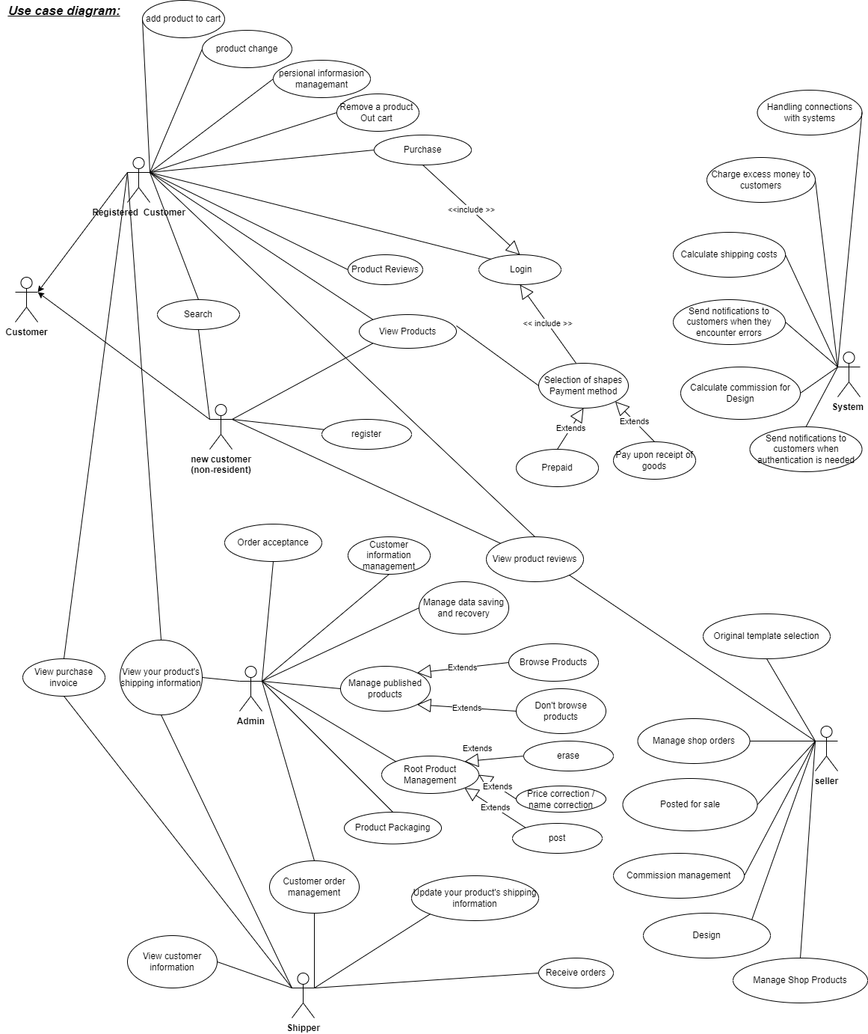

  - Login description
Name | Login
ID | UC_001
Description | Used to access the program and deﬁne the feature accessible depending on the type of account.
Actor | Seller, Customer, Admin, Shipper
Organizational  Benefits | This feature was created to define the features and data that the user can access in the program
Trigger | Login will be automatically activated as soon as we start the program.
Preconditions | Must enter the correct username and password, the database must be connected, accounts must be made available.
Postconditions | Success: user has logged into the system, the main menu of the program must be displayed.  Fail: user haven't logged into the system
Main Course | - Input username and password  - Verify login  - Show main menu
Alternate Courses | AC 2.1: User enters wrong username, password  - Display message error  - Show the login screen again  - Re-enter request  AC2.2: Username and password exists  - Show successful login message  - Show main menu
Exception | EX 1.1: Input Username/Password  - Display: “Invalid username or password, please re-enter!” and ask to re-enter until correct  - Request to re-enter username and password.  EX 2.1: Disconnect to database  - Step 1: Display “Error!!! Can’t connect to database”  - Request to recheck internet connection

  - Product browsing description
Name | Browse products
ID | UC_002
Description | Used to browse the products of the shops before putting them on the web
Actor | Admin
Organizational  Benefits | This feature is created to manage products sold on the web, avoiding inappropriate products
Trigger | Product browsing will be activated in the waiting product section as soon as the seller posts the product
Preconditions | The seller must post the product
Postconditions | Success: admin approves the product, the product must appear on the web. admin removed the product, the program displayed the message message sent to the seller  Fail: admin has not approved the product
Main Course | - Display the product list in the pending products section  - choose to browse or remove
Alternate Courses | 2.1 Admin chooses to browse products  1.The product will be displayed on the web platform  2.Notice of approved product sent to the seller  2.2 Admin chooses to remove the product  1.show mess item  2.admin enter the message or not  3.Notice is sent to the seller
Exception | EX 1.1: Disconnect to database  - Step 1: Display “Error!!! Can’t connect to database”  - Request to recheck internet connection

  - Search description
Name | Search
ID | UC_003
Description | The system supports product search function so that users can find the products they want.
Actor | Customer, Admin, Shopper
Organizational  Benefits | This feature is made for product search
Trigger | The feature will be automatically activated as soon as the customer selects the product search function on the website.
Preconditions | the user chooses the product search function on the website.
Postconditions | Success: product found site  Failed: product does not exist
Main Course | - Product search form appears allowing customers to choose what to search for  - Check the keywords customers enter to find products.  - Notify the product has been found.  - Display products that customers need to find.
Alternate Courses | AC 2.1: The system Notifies the customer that the content to be searched has not been selected.  AC 2.2: The system notices that there is no product that the customer is looking for.
Exception | EX1: Disconnect to database  - Request to recheck internet connection.  - Request program restart.

  - Post product description
Name | Post product
ID | UC_004
Description | product listing function after the design is completed
Actor | Shopper
Organizational  Benefits | his feature is created to help sellers post products after designing
Trigger | the function of posting for sale will be automatically activated as soon as the shop is finished designing and saving.
Preconditions | the shop must successfully log in to the shop owner account.
Postconditions | successful: product is posted and approved by admin  failed: product was only saved to draft or not approved
Main Course | - Design interface display  - The seller chooses to post the product  - The screen displays a message that the product has been placed in the waiting section
Alternate Courses | AC 2.1: The system announces that the product has been successfully pushed or failed  AC 2.2: Product approval or disapproval notification system
Exception | EX1: Disconnect to database  - Request to recheck internet connection.  - Request program restart.

  - Design product description
Name | Design
ID | UC_005
Description | The system supports design functions that help sellers design products according to their ideas
Actor | Seller
Organizational  Benefits | This feature is made for product design
Trigger | the design function will be automatically activated as soon as the seller chooses the design function.
Preconditions | the shop must successfully log in to the shop owner account.
Postconditions | successful: can design the original product  failed: can't design on original product
Main Course | - Display design interface that allows users to design  - Show save, post, and product descriptions
Alternate Courses | AC 2.1: The system informs that your product has been saved.  AC 2.2: The product notification system contains inappropriate information.
Exception | EX1: Disconnect to database  1 Request to recheck internet connection.  - Request program restart.  EX 2: This design is duplicated >75%.  1 Ask you to revise the design.

  - Update cart description
Name | update cart
ID | UC_006
Description | Customers can update any product in their cart.
Actor | Customer
Organizational  Benefits | This feature is created for customers to update their cart before making a purchase
Trigger | Cart update will be activated when the customer selects the functions of adding, editing, and deleting products in the cart.
Preconditions | Customer chooses shopping cart
Postconditions | Success: add, edit, delete product successfully  Failed: can't add, edit product to cart
Main Course | - Show list of products in cart  - Customers choose the functions of adding, editing and deleting products  - Notification of successful cart update
Alternate Courses | AC 2.1: The system notifies the customer that there are no products in the cart  AC 2.2: The system says can't add products  AC 2.3: The system notifies the confirmation when the customer chooses to delete the product
Exception | EX1: Disconnect to database  - Request to recheck internet connection.  - Request program restart.

  - Invoice detail description
Name | Invoice detail
ID | UC_007
Description | Used to view invoice details
Actor | Customer
Organizational  Benefits | You can view all product price and total amount to be paid
Trigger | Purchase invoice will be automatically activated as soon as an order is placed in the cart
Preconditions | There must be products in the cart and the user chooses to view purchase invoices.
Postconditions | Success: Purchase invoice display  Failed: Customer has not added any products to the cart
Main Course | - shopping cart display  - Customers choose to view invoices  - Purchase invoice display
Alternate Courses | AC 2.1: There are no products in the cart  - The screen shows an error message because there are no products in the cart  - Ask the user to add the product to the cart
Exception | EX1: Disconnect to database  - Request to recheck internet connection.  - Request program restart.

  - Payment description
Name | Payment
ID | UC_008
Description | Used for customers to choose the appropriate payment method and pay
Actor | Customer
Organizational  Benefits | This feature is created to help customers pay in many forms
Trigger | The payment function will be activated when the customer has confirmed the purchase and selected the payment method
Preconditions | The customer must confirm the purchase
Postconditions | Success: customer payment successful  Failed: customer has not selected a payment method, payment has not been successful
Main Course | - The screen displays the payment methods for customers to choose  - Customers choose a suitable payment method  - Customer confirms payment method  - Successful message
Alternate Courses | AC 2.1: Customers choose online payment method  - Show banks for customers to choose to pay  - Customers enter the amount to pay  - The system sends a confirmation message to the customer's email  - Customer confirms email  - Notice of successful payment
Exception | EX1: Disconnect to database  - Request to recheck internet connection.  - Request program restart.  EX2: Customers paying online have not paid the full amount  - The system sends a notice that the customer has not paid the full amount  - Ask the customer to pay the full amount

- Activity Diagram
  - Login

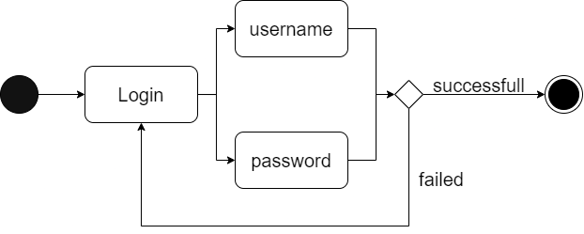

  - Registration

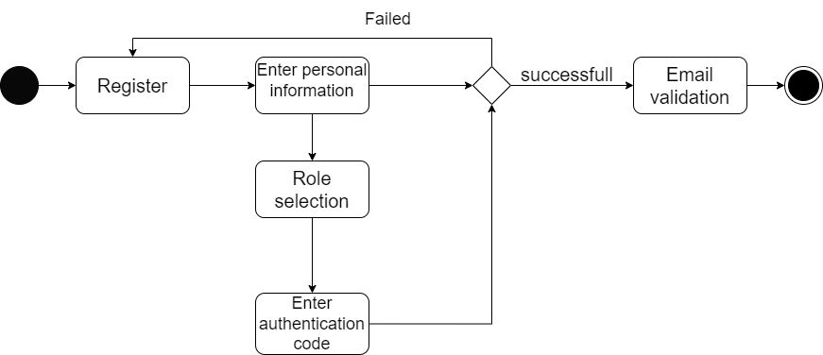

  - Search

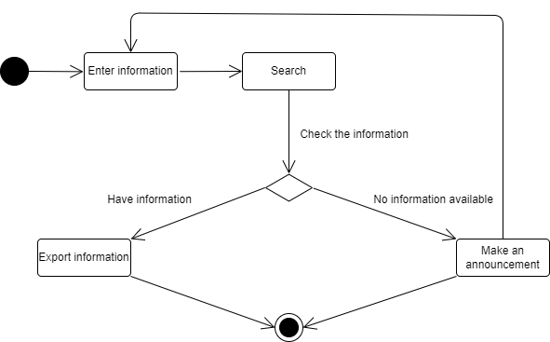

  - Payment

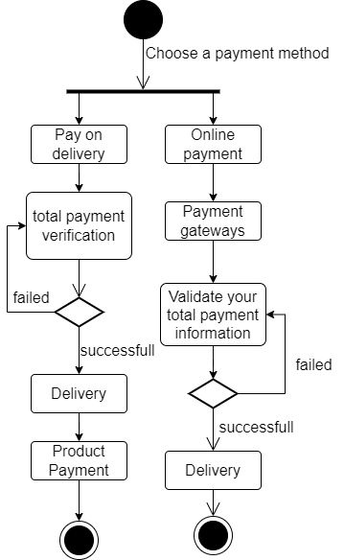

  - Add to cart

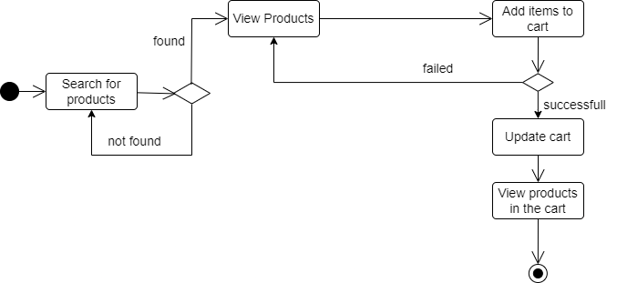

  - Post products
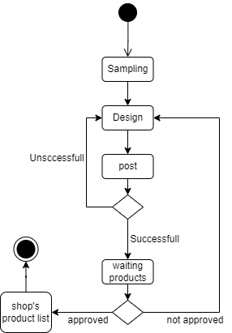

  - Browse products

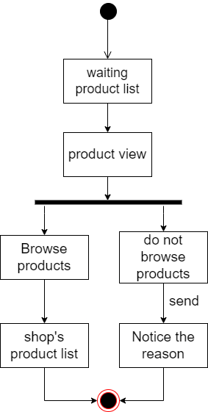

- Design Details
- UI Design
  - Login

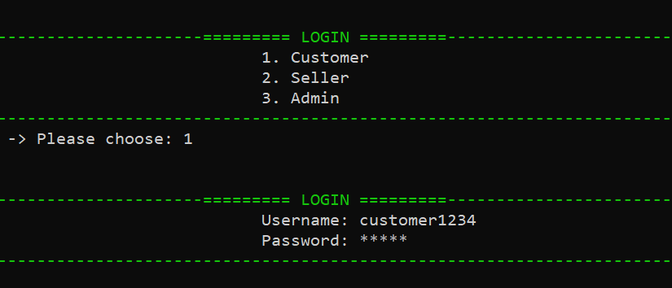

  - Menu customer

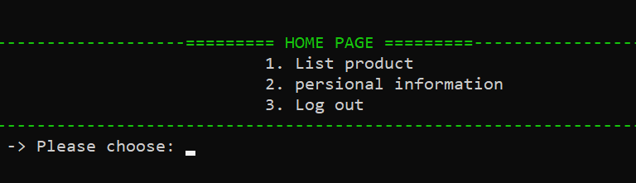

  - List product

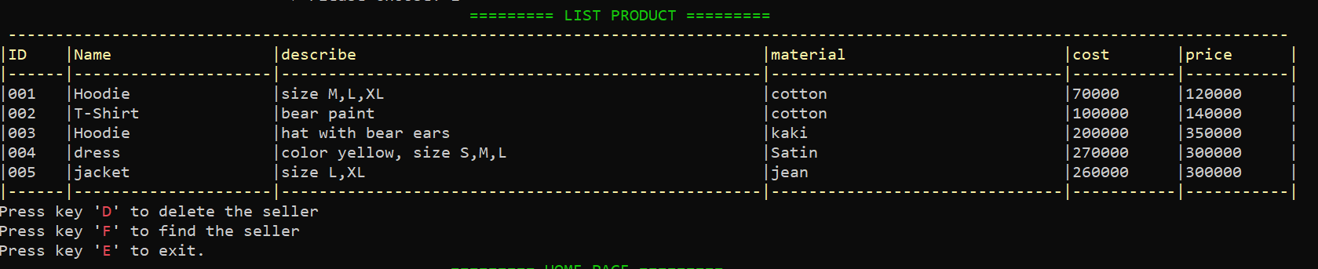
  - Menu seller

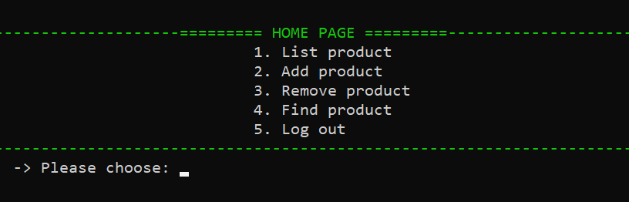

  - Add product

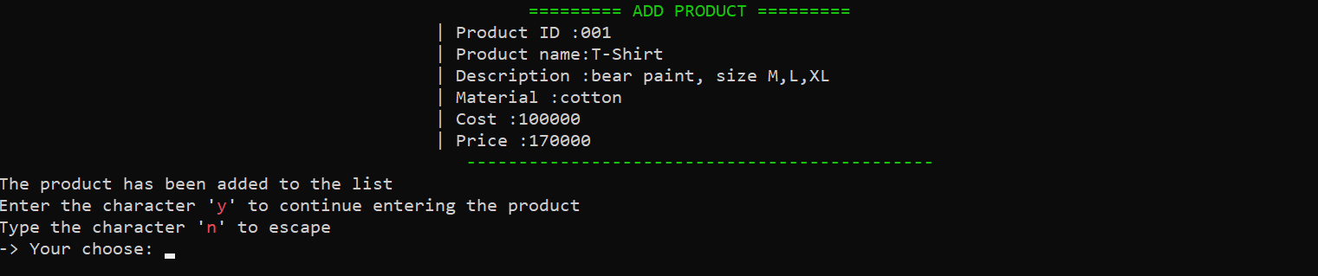

  - Menu admin
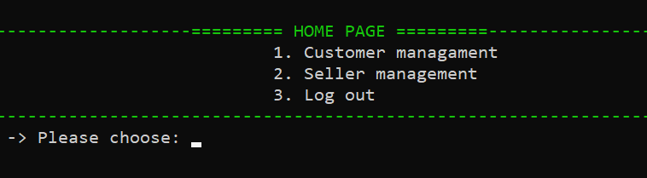

  - List customer

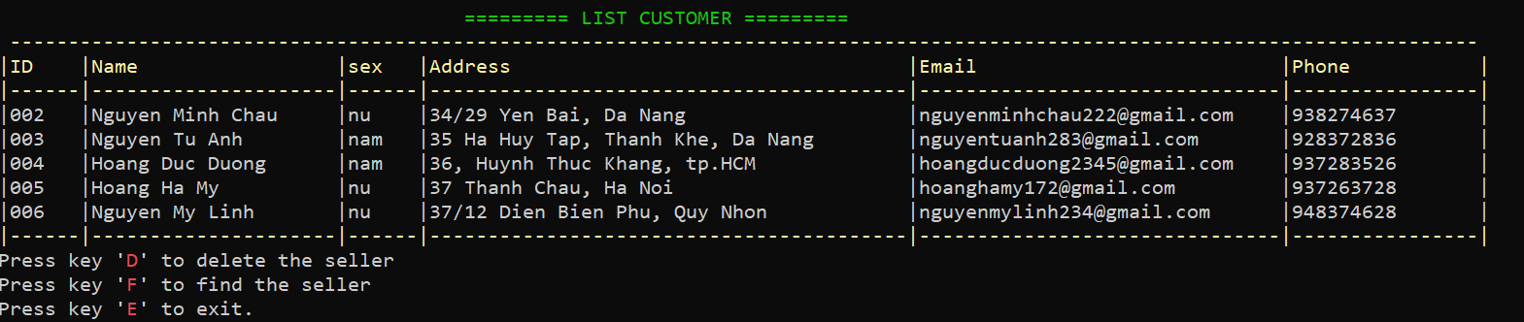

  - List seller
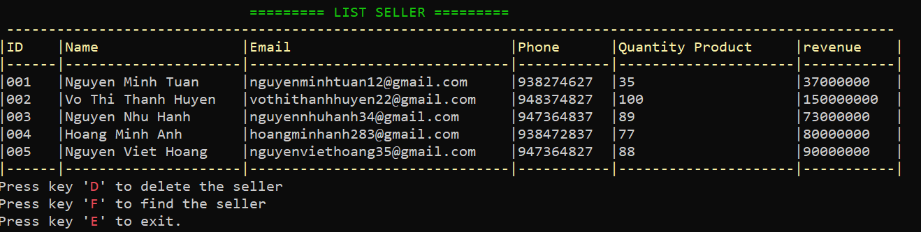
- Code Design (Class Diagram)
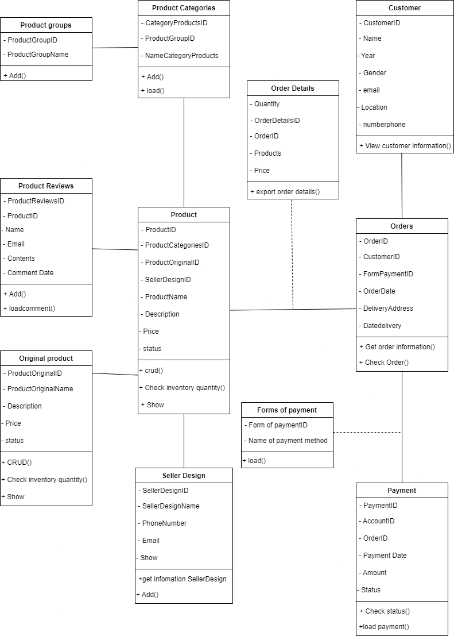
- Sequence Diagram
  - Login

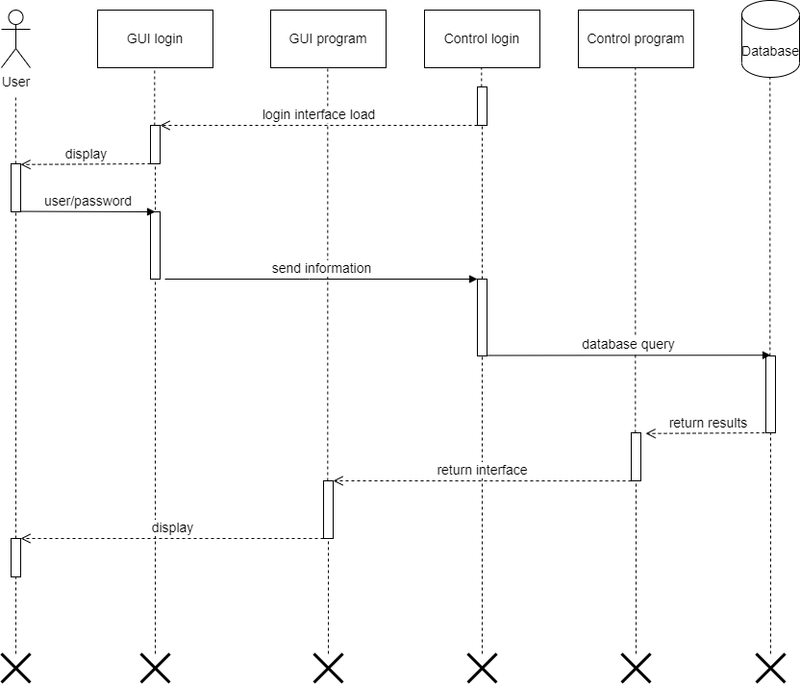

  - Search

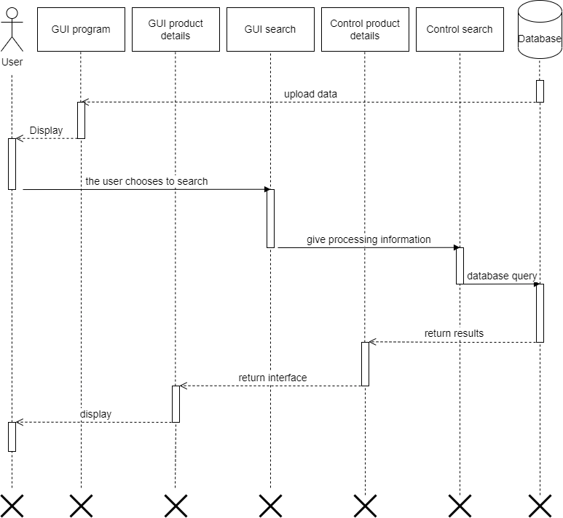

  - Add product to cart

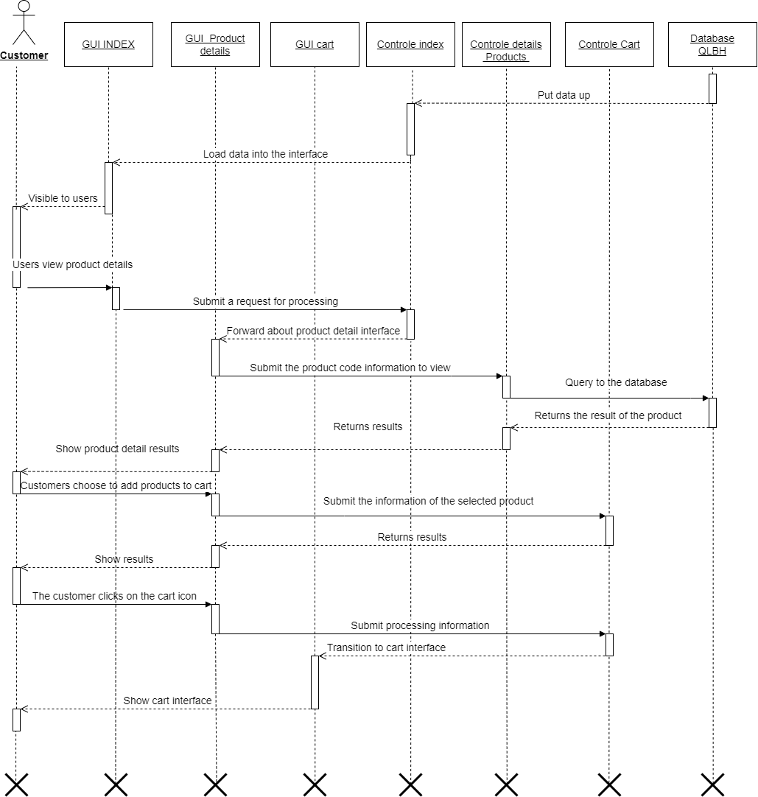

  - Post products

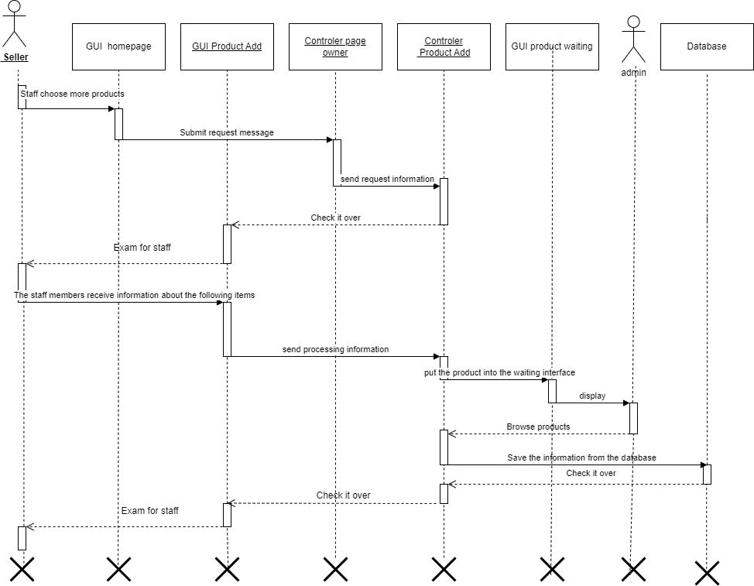

  - Order

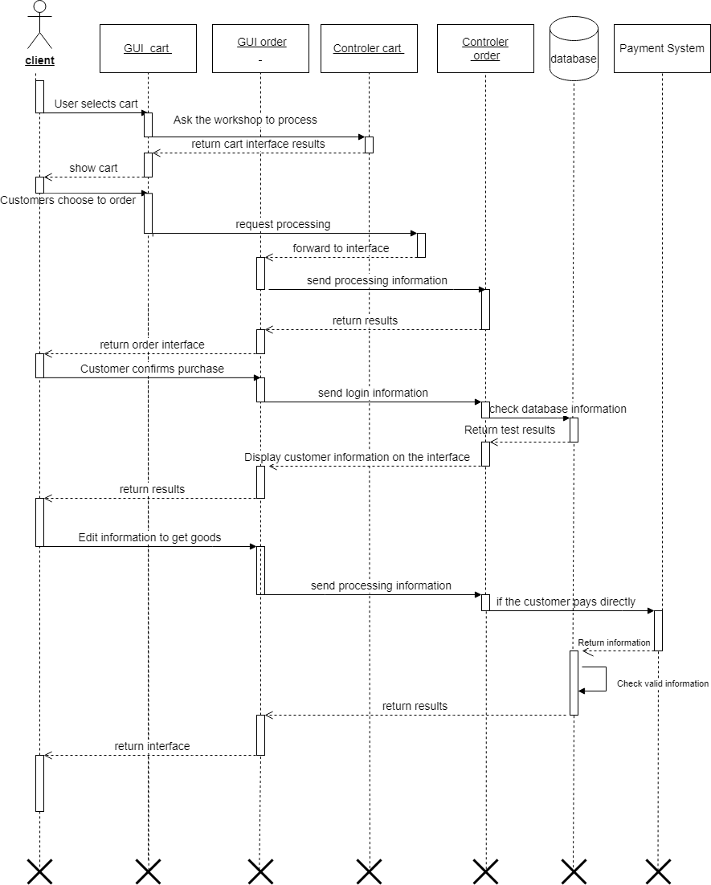

- Database Design
  - Entity relationship diagram

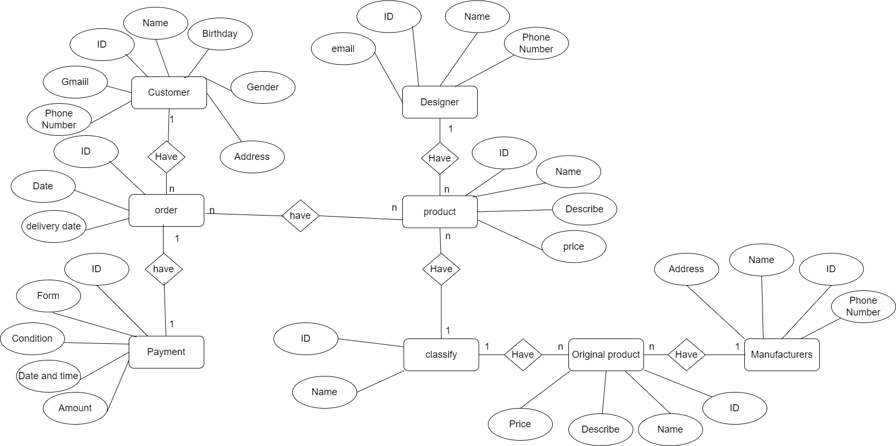

  - Database Design Details
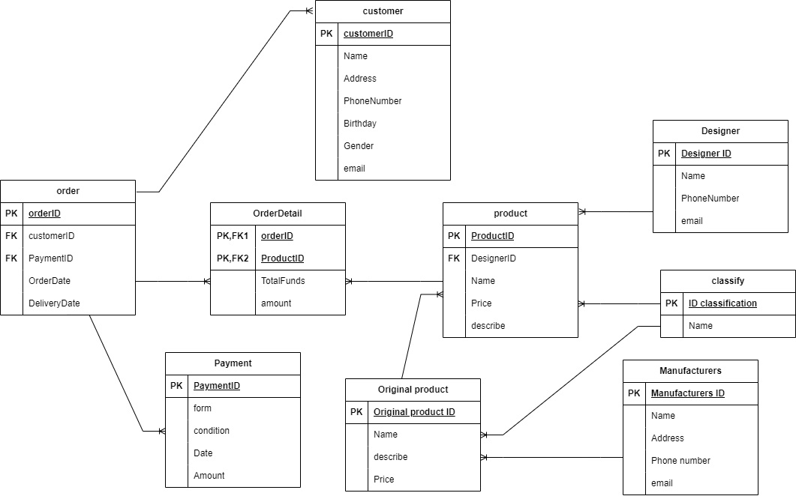

Customer
Column Name | Data Type | Constraints | Description
customerID | int | PRIMARY KEY, AUTO  INCREMENT
name | varchar(255) | NOT NULL
address | varchar(255) | NOT NULL
phone | int | NOT NULL
birthday | datetime | NOT NULL, CHECK LESS THAN CURRENT DAY
gender | varchar(25) | NOT NULL
email | Varchar(255) | NOT NULL

Order
Column Name | Data Type | Constraints | Description
orderID | int | PRIMARY KEY, AUTO  INCREMENT
customerID | int | FOREIGN KEY
paymentID | int | FOREIGN KEY
OrderDate | datetime | NOT NULL, DEFAULT CURRENT DATE
DeliveryDate | datetime | NOT NULL

Order Details
Column Name | Data Type | Constraints | Description
orderID | int | PRIMARY KEY, FOREIGN KEY
productID | int | PRIMARY KEY, FOREIGN KEY
totalFunds | decimal | NOT NULL
quantity | int | NOT NULL, CHECK MORE THAN 1

Payment
Column Name | Data Type | Constraints | Description
paymentID | int | PRIMARY KEY, AUTO  INCREMENT
form | varchar(255) | NOT NULL
condition | varchar(255) | NOT NULL
date | datetime | NOT NULL, DEFAULT CURRENT DATE
amount | int | NOT NULL

Seller
Column Name | Data Type | Constraints | Description
sellerID | int | PRIMARY KEY, AUTO  INCREMENT
name | varchar(255) | NOT NULL
phone | int | NOT NULL
email | Varchar(255) | NOT NULL

Product
Column Name | Data Type | Constraints | Description
productID | int | PRIMARY KEY, AUTO  INCREMENT
sellerID | int | FOREIGN KEY
OProductID | int | FOREIGN KEY
name | varchar(255) | NOT NULL
price | decimal | NOT NULL
describe | Varchar(255) | NOT NULL

Original product
Column Name | Data Type | Constraints | Description
OProductID | int | PRIMARY KEY, AUTO  INCREMENT
name | varchar(255) | NOT NULL
describe | varchar(255) | NOT NULL
price | decimal | NOT NULL

Manufacturers
Column Name | Data Type | Constraints | Description
manufacturerID | int | PRIMARY KEY, AUTO  INCREMENT
name | varchar(255) | NOT NULL
address | varchar(255) | NOT NULL
phone | int | NOT NULL
email | Varchar(255) | NOT NULL

Classify
Column Name | Data Type | Constraints | Description
classifyID | int | PRIMARY KEY, AUTO  INCREMENT
name | varchar(255) | NOT NULL

- TaskAssign ( to each team member)
Group  4 | Website design and sell
No | Task name | Descriptio n | Start Date | End Date | Member | Self  assessme nt
1 | Write report |  | 1 April | 15 April | Huyen
2 | Code C# |  | 10 April | 15 April | Huyen & Hieu & Linh
3 | Analysis |  | 30 March | 5 April | Huyen & Hieu & Linh
4 | Design Figma |  | 9 April | 15 April | Huyen & Hieu & Linh
5 | Design database |  | 9 April | 15 April | Huyen
6 | Powerpoint |  | 15 April | 18 April | Hieu

- Experience learned
Analyze : Use case, Class diagram, Activity diagram
Design : c#, figma, database
Teamwork skills
Reporting skills
Presentation skills
Communication skills
Decision skills
Time management skills

_____ The end - Thank you for reading_____

